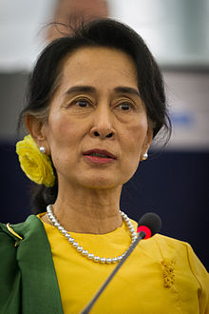

Aung Sang Suu Kyi

One of her most famous speeches was Freedom From Fear*, which began: "It is not power that corrupts, but fear. Fear of losing power corrupts those who wield it and fear of the scourge of power corrupts those who are subject to it.”*

She also believes fear spurs many world leaders to lose sight of their purpose. "Government leaders are amazing", she once said. "So often it seems they are the last to know what the people want.”

Tags

Democracy, Decolonization, Governance, Peace and Security, Human Rights